SPRING GREEN FIRE AND EMS WILL BE HOSTING AN OPEN HOUSE!

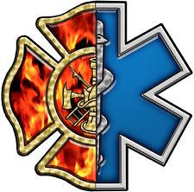

Saturday, May 3, 2025

11am-3pm

We are excited to invite the community into the station to see what we do and remind our neighbors how to stay safe when an emergency arises.

FREE ADMISSION!

This awareness day will include:

Fire truck rides

Fire hose spray competitions

Jaws of life demos

DNR/WI River Project: life jacket safety, canoe/boating safety

Bike Safety; please bring your own bike

Med Flight

SG Police, Sauk County Sheriff, K9, Swat, & Drone Demos

Alliant Energy Wires and Fires

Free blood pressure and blood sugar check

A variety of items to raffle

Hot dogs, brats, chips, and water for sale

**Thank you in advance for supporting**

**Spring Green Fire and EMS.**

**We look forward to seeing you on May 3rd!**